# Quick SourceTree Guide

## Interface

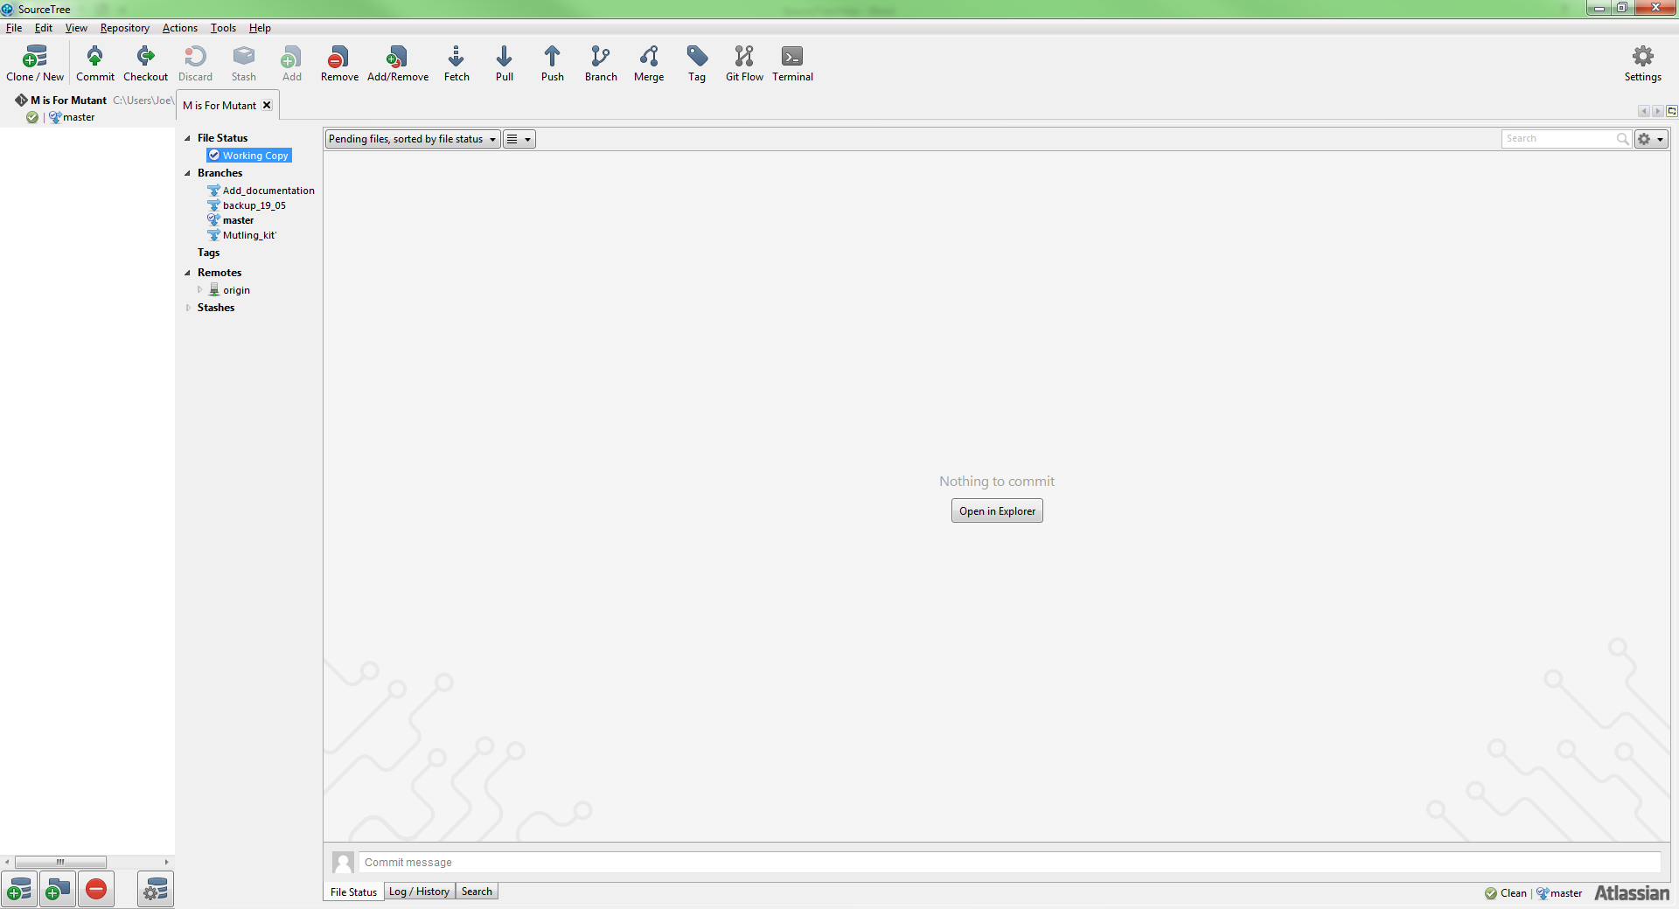

##### Clone:

Used to initially setup the online repo on the desired machine.

##### Commit:

Similar to saving a word document, when you are finished making changes use commit to save the changes to the branch you are working on. You will be prompted to give a summary. A short explanation of what has been changed/created is ideal.

##### Checkout:

Used to change which branch you are on, you can also just double click on the branch in the branches drop down.

##### Stash:

Used to discard current changes on the current branch, this will restore the branch to the last successful commit.

##### Pull:

Used to download commits from the online repository. (Be sure to always pull the master branch before merging onto it or creating a branch from it!)

##### Push:

Used to upload commits from your local machine to the online repository.

##### Branch:

Used to create parallel variations of the master copy. Always make a branch when making changes, working on the master branch can quickly and easily cause conflicts which suck.

# Quick reference checklist

## Creating a new branch

1. Checkout the master branch (double click master in branch drop down).
2. Pull, as changes may have been uploaded to the online repository.
3. Click the branch button  and name the branch accordingly.

## Committing changes on the new branch

1. 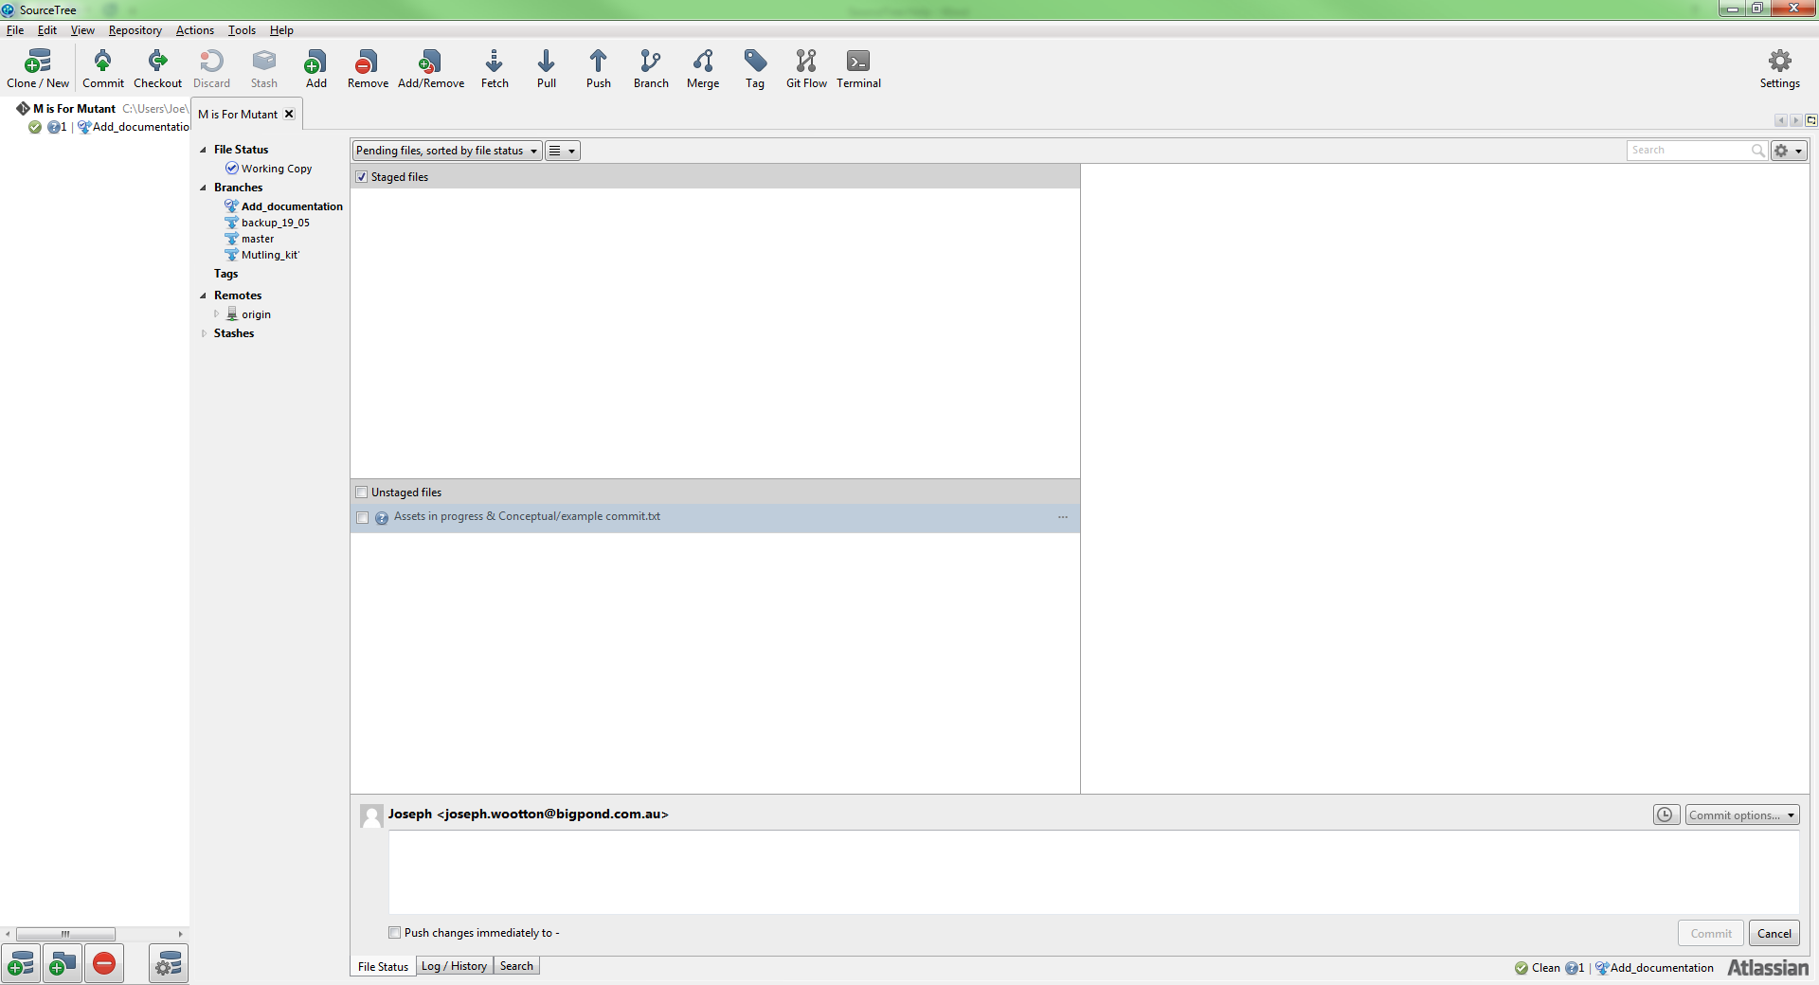 tick the unstaged files box to stage all files for the commit.
2. 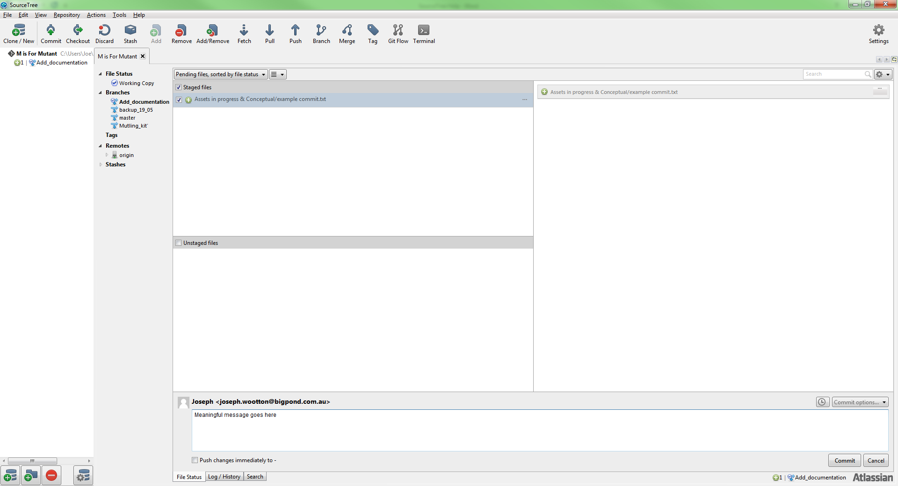 All of the files should now be staged. Fill in the text box down the bottom with a meaningful, short and concise description of the changes and then press the commit button in the bottom right.

## Committing changes on the new branch

1. When you want to get your branch changes onto the master branch, the first step is to checkout the master branch (once again double clicking).
2. Do another pull to get the latest version from the online repo.
3. Right click the branch you wish to merge and select the merge into current branch option. 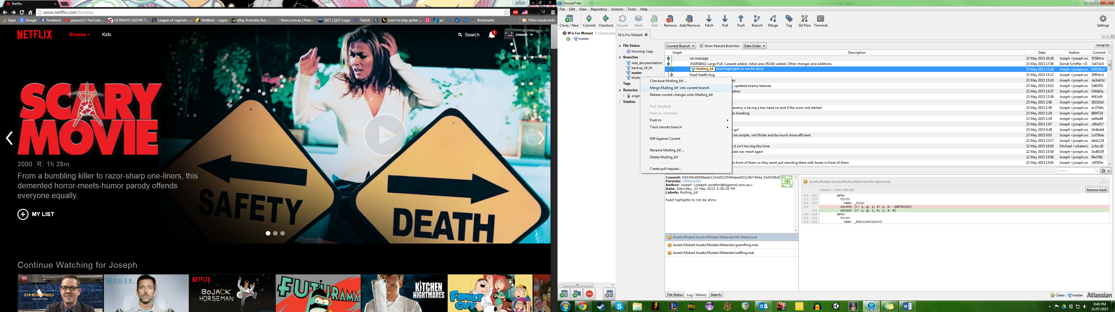
4. Once you have merged the branches push the newly updated master so it is on the online repo for everyone else.

## Cautions/Extra tips

* All additions to the scene should be done with the use of prefabs so they can be updated without changing the scene.
* Two people cannot work on the same specific file separately without causing conflicts so communication and organisation are key!
* If you make changes to something you don’t wish to commit you can untick specific changes in the list so they are in the bottom section and when you commit they will not be part of it. From there you can do a stash to remove all the excess/unwanted changes.